Our services

1: Ocean Freight : 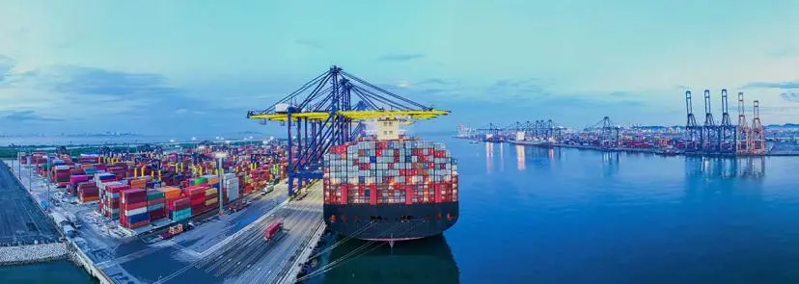

Freight Systems provides a dependable and integrated ocean freight service that puts the customer first. With trained personnel on the ground at ports across the world and partnerships with best-in-class global and regional carriers, we offer a robust and flexible range of global and local Ocean Freight services for both Less-Than-Container Load (LCL) and Full-Container Load (FCL) shipments. With direct consolidation to 18 countries serving 200 ports, our LCL experts bring in a deep understanding of the markets and network to offer customized and innovative solutions with full accountability and transparency. ‍  
  
With dedicated Container Freight Stations (CFS) at all major Freight Systems gateways, we can adapt to your needs by offering multi-modal transport with door-to-door delivery if required. Speak to our team to get a customized, integrated solution that works for you.

2. Air Fright : 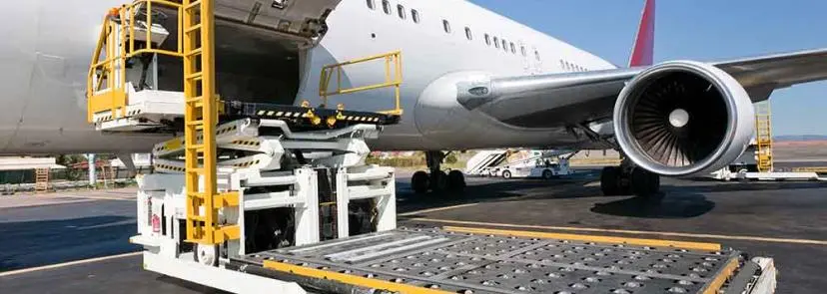

As a major global air freight forwarding company, Freight Systems offers a wide range of international air services and customized solutions to meet ever-changing customer needs and faster delivery requirements. ‍  
  
As an IATA-approved company, we have strategic alliances with prime carriers across all major commercial destinations. Our knowledgeable team is on the ground at both origin and destination to ensure your shipments arrive on time and safely to destinations across the world. ‍  
  
We are fully equipped to handle charters for special projects, oversized cargo, and dangerous goods. Each shipment is handled with care by our expert staff to ensure your goods reach you safely, no matter what. And with a full suite of transportation services, we can develop a multi-modal plan that best suits your needs. Speak to our team to get a customized, integrated solution that works for you.

3. Road Fright : 

Freight Systems offers a streamlined road cargo transportation service ensuring your goods are travelling on the most efficient route. Having years of experience working with trusted partners, we provide an extensive network and reliable services to meet all your needs on the road.

4. Multi Modal Services 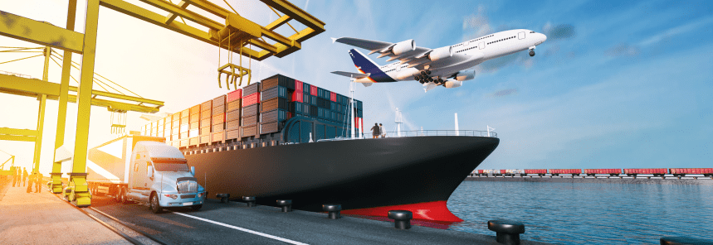

At Freight Systems, we are industry leaders in designing and managing end-to-end multi modal solutions like Sea-Air and Sea-Sea services that combine the separate strengths of each form of transportation. Our Sea-Air service is a timely and cost-effective solution that combines the lower costs of sea freight with the speed of air freight. Ideal for non-urgent shipments, the service retains all the value-added services standard to our air freight with substantial savings on the overall transportation costs, all while maintaining a fast transit time.  
  
Let our experienced team help you maximize efficiencies and manage costs, serving as a single point of contact to create the right logistics solution for your needs.

About us :

UKF Sea And Cargo services is a global freight forwarding company offering end-to-end solutions backed by technology and expertise, including Transportation Services, Contract Logistics, Customs Clearance, Project Logistics.   
We provide services to our customers that maximize savings and time by following a simple action plan: we identify customer needs, create innovative and timely solutions, improve efficiency, and communicate transparently.

As a pioneer in LCL consolidation, Freight Systems has been providing logistical solutions for more than three decades and now offers a full range of services, transporting more than 100,000 TEUs of freight per year to over 350+ locations across six continents.

Resources:

1: Blogs:

**Navigating Regulatory Changes in Freight Forwarding**

In today’s global marketplace, international trade is becoming increasingly complex as businesses of all sizes aim to expand into new markets. Unlike domestic shipping, navigating international trade involves more than just overcoming cultural and language barriers; it requires managing a maze of customs regulations. Failure to comply with these regulations can lead to costly fines, shipment delays, and a damaged reputation. In the ever-changing landscape of freight forwarding, keeping up with regulatory shifts is essential for success. These changes can stem from new trade agreements, geopolitical factors, and stricter security and environmental requirements.

At Freight Systems, we understand these challenges and are here to help you navigate them, ensuring your shipments are smooth, compliant, and on time. In this blog, we’ll cover the fundamentals of regulatory compliance, why it matters, and offer practical advice for managing customs regulations, while showcasing how our customs services can streamline your logistics operations.

**Safety Standards in Freight Forwarding**

In the fast-paced world of freight forwarding, safety is paramount. Whether transporting goods by air, sea, or land, ensuring that cargo arrives safely at its destination is the primary responsibility of any freight forwarding company. At Freight Systems, we understand the importance of adhering to the highest safety standards to protect not just the cargo, but also the people, infrastructure, and environment involved in the supply chain. Here we will explore the critical safety measures implemented in freight forwarding and how they contribute to reliable and secure global logistics operations.

**The Importance of Safety Standards in Freight Forwarding**

Safety standards in freight forwarding are the cornerstone of a successful logistics operation. The intricate nature of global supply chains means that even a minor lapse in safety protocol can lead to significant delays, loss of cargo, or increased operational costs. For companies involved in freight forwarding, especially those working with high-value or hazardous goods, these standards are not just a legal obligation but a crucial part of their reputation and reliability.

In regions like the United Arab Emirates, where logistics hubs such as Dubai play a vital role in global trade, the adherence to international safety standards ensures that shipments pass smoothly through checkpoints, avoiding unnecessary delays or penalties. By prioritizing safety, freight forwarders can guarantee the seamless movement of goods across borders.